Megan Shaw

Challenge Proposal

Purpose:

The purpose of this site will allow a user to build a Pokémon Team up to six Pokémon using the latest generation of game data.

Audience:

The target audience of this application are those who play the Pokémon video games and/or play competitive Pokémon battles.

Data Sources:

The main data used for this application will be the Pokémon API found at pokeapi.co. LocalStorage will also be involved to save the Pokémon team data.

Wireframes:

Small View

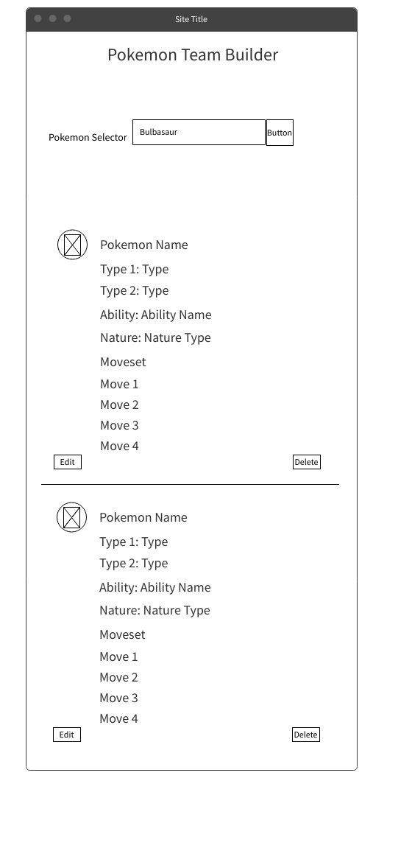

Larger View

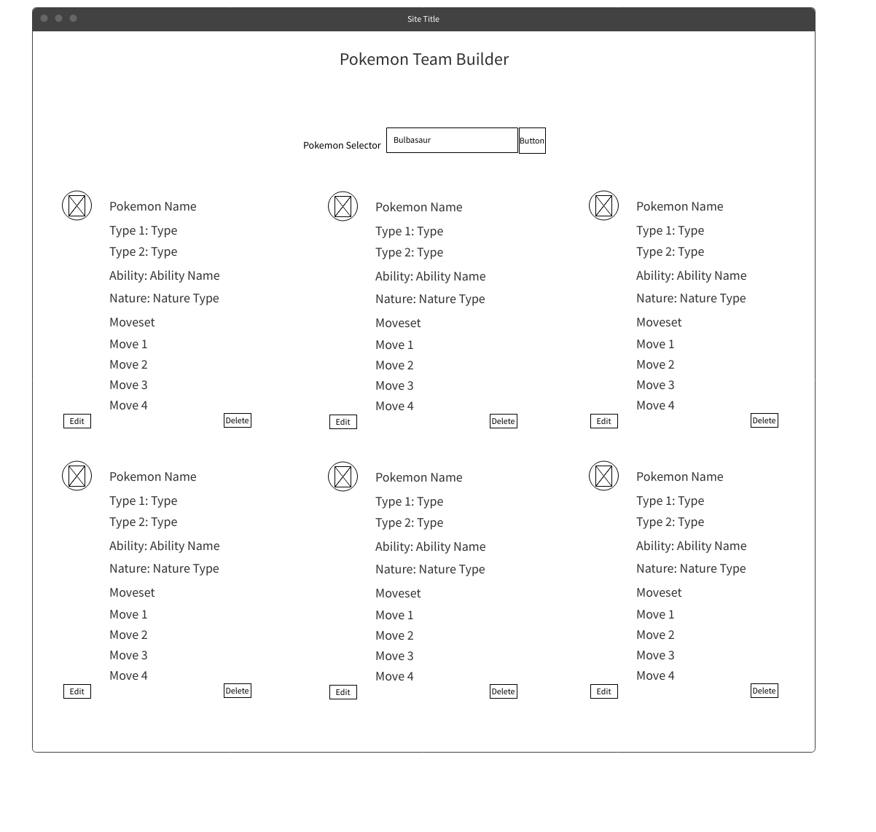

Modal on both views (this opens after a user selects a Pokémon on either the small or larger view)

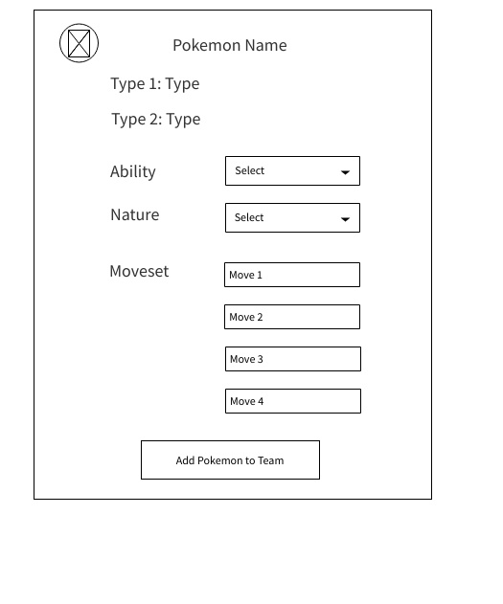

Color Scheme:



Typography

Main Text: Hind

Heading Text: Press Start 2P

Schedule

Week 10

* Outline functions needed to accomplish goals
* Begin HTML code with ids, classes, and forms

Week 11

* Import fonts
* Create function to search, select Pokémon, and open modal for customization.
* Store selection to localStorage
* Display Pokémon name on screen

Week 12

* Create functions for modal that will allow user to select ability, nature, and moves.
* Store these selections in localStorage
* Display selections on screen

Week 13

* Create edit and delete buttons for Pokémon already displayed
* Add styling for small and wide screens

Week 14

* Test
* Continue styling
* If time allots, add a held item selection to Pokémon customization